Fuel cell – fill in the gaps
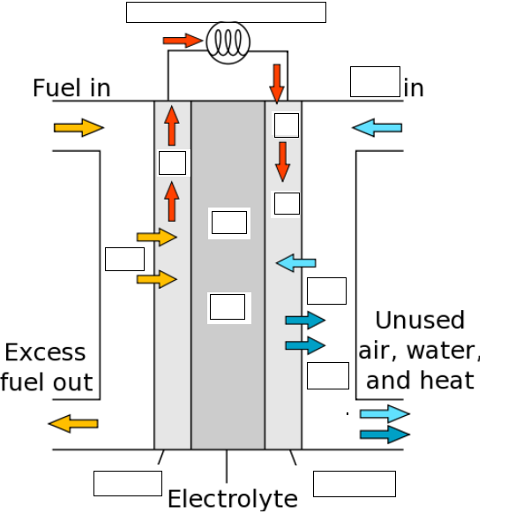

Anode reaction:

Cathode reaction:

Overall reaction:

